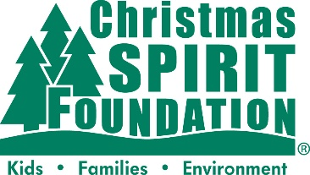

***MEDIA ADVISORY***

Special Delivery by FedEx Freight will bring Christmas Spirit to [Insert Base Name]

WHAT: FedEx Freight will deliver an estimated [Insert Number] fresh, farm-grown Christmas trees to military families at [Insert Base Name] as part of the Trees for Troops program. The trees will be given away on [insert date of your event] to [include base personnel/families eligible to receive a tree].

[Insert Base Name] is proud to provide this service as a show of support for our military families. Trees for Troops is a program of the Christmas SPIRIT Foundation and tree farmers across the country to support the true spirit of the holiday season for U.S. troops and military families. This is the 17th year FedEx Freight has delivered on behalf of the program.

WHERE: [Insert Tree Delivery Location]

WHEN: [Insert Date and Time]

CONTACT: [Base Media Contact], [Phone Number], [Email]

About FedEx Freight
Since 2001, connecting customers with opportunity has motivated the people of FedEx Freight, a subsidiary of FedEx Corp. (NYSE: FDX) and a leading provider of LTL freight services. We revolutionized the LTL industry with the priority and economy model, and we offer our customers both fast-transit delivery of time-sensitive freight (FedEx Freight Priority has the fastest published transit times of any nationwide LTL service) or cost-effective delivery when they can trade time for savings. Through more than 370 service centers and 25,000 motorized vehicles, FedEx Freight moves more than 115,000 LTL shipments each day throughout the U.S., Canada and Mexico. With a steadfast focus on Safety Above All, our 45,000 team members are driven to innovate for our customers and give back to the communities where we live and work. To learn more, please visit about.fedex.com.

About the Christmas SPIRIT Foundation and Trees for Troops
The Christmas SPIRIT Foundation is a 501(c)(3) tax-exempt charitable organization that works to recognize and support the true spirit of Christmas through programs like Trees for Troops®. The foundation was established in 2005 and is among fewer than five percent of U.S. charities to be awarded the “Best in America” seal of excellence by Independent Charities of America. To learn more visit www.christmasspiritfoundation.org.
# # #

